Per Erik Haram
DS Nor AS
peh@ds-nor.no 24.10.2025 HP11109-1

PRICE OFFER

Project: 30480 Akkasæter Lager - og vedlikeholdshall
Project address: Akkasæter, Målselv kommune, Norway
Price offer is calculated according to your documentation sent via e-mail on 22.10.2024
Price offer quantities are based on „DS-Material_list_Phase 1+2.xlsx“ and „DS-Material_list_Phase 3.xlsx“
PRICE, VAT 0%
No. | Name | Surface | Amount | Unit | Price, € | Unit price
1. | Manufacturing |  | 148 315 | kg | 272 219
 | Phase 1 + 2
1.1 | Columns | C2M | 35 141 | kg | 68 314 | 1,94
1.2 | WQ beams (including connections) | primer, lower flange painted C2M | 11 381 | kg | 22 637 | 1,99
1.4 | Beams | C2M | 75 914 | kg | 131 863 | 1,74
1.5 | Bracings | C2M | 12 601 | kg | 23 161 | 1,84
1.6 | Window- and door frames (ifc yellow elements) | C2M | 10 276 | kg | 18 877 | 1,84
 | Phase 3
1.7 | Outside entrance steel | HDG | 2 714 | kg | 6 413 | 2,36
1.8 | Indoor bollard (tubes) | HDG | 288 | kg | 954 | 3,31
2. | Bracings D30 with turnbuckles  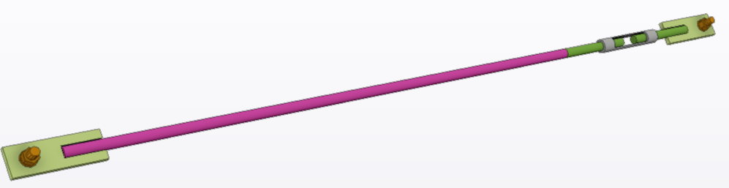 |  | 72 | pcs | 17 564 | 243,94
3. | Hilti anchor HUS4-HF |  | 150 | pcs | 935
4. | Fasteners for steel-to-steel connections |  | 1 | set | 5 302
5. | Transport:  - 5 pcs standard truck 2,4x2x6x13,5 m;  - 4 pcs long truck 2,4x2x6x15m. |  | 1 | set | 37 375
 | TOTAL: |  |  |  | 333 395

Delivery terms: DAP Akkasæter, Målselv kommune, Norway
Delivery time:
week 44/2025 - material/parts list for purchasing materials
week 44-45/2025 (?) - workshop drawings
week 2-3/2026 - transport to construction site

Offer is valid: 28.10.2025 as preferred decision dated from DS Nor
7 days

The price offer includes:
- Material
- Steel constructions fabrication
- Surface coating according to price table
- Transport

The price offer does not include:
- Erection Works
- Workshop drawings
- Gratings, steps, handrails or anything else not shown in IFC model or listed in price table

ASSUMPTIONS AND REMARKS

- Workshop drawings
Workshop drawings delivered by client will meet the following conditions:
  - All workshop drawings will be in “pdf” and “dwg” format with all necessary dimension lines and info shown on drawings.
  - Tekla generated DSTV files for CNC manuf. machines will be delivered for cutting-drilling plates and profiles.
  - Part list, assembly-part list and assembly list delivered in Excel format
- Materials and fabrication
  - Materials, certificates, fabrication, quality inspection and anticorrosion protection according to EN standards.
  - Quality control and tracing of raw materials according to our ISO 9001 Quality manual.
  - Fabrication of the structural steel according to EN1090-2, execution class EXC2, tolerances acc. class 1.
  - CE marking will be issued by Maru Metall AS according EN 1090-1.
  - Splicing of plates and profiles has been assumed to be permitted.
  - Rectangular, square and circular hollow sections according to the standard EN10219 are accepted.
  - Steel grades S235JR, S355J2, S355J2H with 3.1 certificates. Steel according to EN10025, basic requirements, without options. Steel density for profiles 7,85.
  - For Built-up profiles we assume fillet welding with ≤ a6.
- Surface treatment in our workshop
  - Bevelling of sharp edges 1 x 1 mm only for cut edges and no rounding.
  - No need for rounding of drilled holes – only trimming 0,5 mm/45 degrees.
- Scope of erection
  - Erection works is not included in this offer.
- Transport and packing
  - Transport sizes as described in the price table.
  - Standard packing procedure of Maru has been assumed.
    - Large elements such as columns, main beams etc. will be transported loose – wooden dividers to be used.
    - Smaller elements such as beams, braces, wall elements etc. will be bound with stripes and stacked with dividers made of wood.
    - No special steel frames are used as packages.
    - Packing List according to Maru draft.
- Miscellaneous
  - Contract language is English.
  - We assume that the possible contract will be a unit price contract i.e. the final accounts will be calculated by multiplying unit prices and actual quantities given in the final list of materials.
  - The following are excluded from the scope of the offer: non-carbon steel elements, bending of items, milling and machining.
  - The price offer does not reserve our production resources. Before the purchase order/contract, please coordinate the reservation of the resources.
  - Maru Metall reserves right to change prices if quantities, type of structures or technical demands will be changed.
  - Maru reserves the right to use subcontractors and partners.

Yours sincerely,

Madis Tuuling Oksana Pavlova
Sales Manager Cost Engineer
+3725061810
madis.tuuling@maru.ee

